YOU ARE FOOLED………

* WEBSITE CHUSEVADIVI GOMMANE CHUDAKUNDA 

NEK EM PANI SIDE LO VUNDE IMAGE THO

CHAL LE CHUSINDHI BAYALDHERU TATAAA BYEEEE!!!!! 

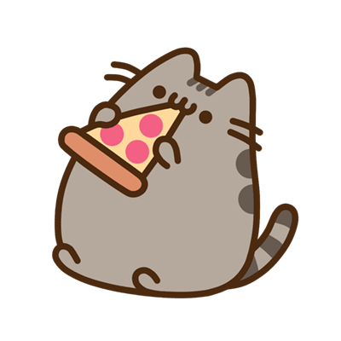PIZZA KAVALAAAA LEDH PEHHH!!!